**Mon_25963_Sylvie_PLSQL_Phase3_Report**

**Phase III – Logical Model Design**

**Course**: INSY 8311 – Database Development with PL/SQL  
 **Lecturer**: Eric Maniraguha  
 **Student Name**: Sylvie Iradukunda  
 **Student ID**: 25963  
 **Date**: March 25, 2025

### **Project Title:**

**Wildlife Poaching Prediction System for National Parks**

### **Objective:**

To develop a normalized, efficient, and relational logical data model to support the proactive detection and response to wildlife poaching activities in Rwanda's national parks.

### **Entity Descriptions:**

**1. Animal**

* animal_id (PK)
* species_name
* gps_collar_id (UNIQUE)
* last_known_location
* status (CHECK: 'endangered', 'common')

**2. Poaching_Incident**

* incident_id (PK)
* animal_id (FK)
* timestamp
* location
* severity_level (CHECK: 'Low', 'Medium', 'High')

**3. Environmental_Data**

* env_id (PK)
* timestamp
* location
* weather
* moon_phase
* vegetation_density

**4. Ranger_Unit**

* ranger_id (PK)
* unit_name
* patrol_area
* contact_info

**5. Incident_Response**

* response_id (PK)
* incident_id (FK)
* ranger_id (FK)
* response_time
* action_taken
* logged_at

### **Relationships:**

* One Animal can be involved in many Poaching_Incidents (1:N).
* Each Poaching_Incident may result in one Incident_Response (1:1).
* One Ranger_Unit can respond to many incidents (1:N).
* Many Poaching_Incidents may reference the same Environmental_Data snapshot (M:1).

### **Constraints:**

* NOT NULL on essential fields (e.g., PKs, foreign keys)
* UNIQUE constraint on gps_collar_id
* CHECK constraints for predefined statuses and severity levels
* DEFAULT values as needed for data consistency

### **Normalization:**

The logical model adheres to **Third Normal Form (3NF)**:

* All attributes are atomic (1NF)
* All non-key attributes depend fully on the primary key (2NF)
* No transitive dependencies (3NF)

### **ERD Diagram:**

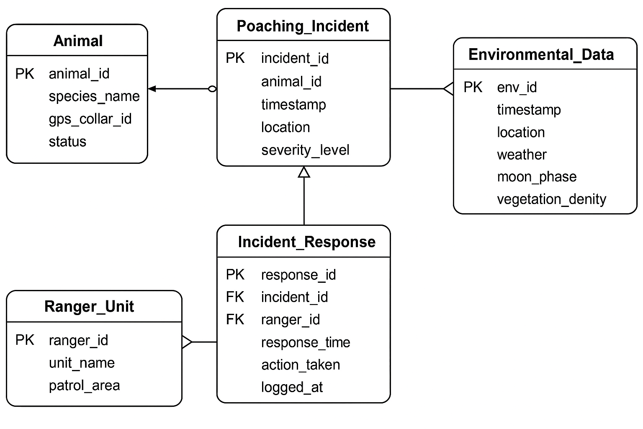

The ERD shows the entities and their relationships using crow’s foot notation. It clearly defines primary and foreign keys, as well as entity associations to ensure referential integrity.

**End of Phase III**